Serverless Development 101

**Module 05B – The Web Application using Serverless Computing- Search Function**

2/17/2019 Developed by Kevin Wang

2/11/2019 Revised by Sam Chung

4/20/2020 Updated by Apiwat Chuaphan

Center for Information Assurance (CIAE) @City University of Seattle (CityU)

  

**Learning Outcomes**

* Learn how to scan a DynamoDB table.
* Learn how to make an API call from the front-end.
* Learn how to use the jQuery UI library.
* Learn how to deploy a fetching API with Lambda.

[**jQuery**](https://jquery.com/)

jQuery is a lightweight, "write less, do more", JavaScript library. The purpose of jQuery is to make it much easier to use JavaScript on your website. jQuery is probably the most popular, and also the most extendable.

jQuery takes a lot of common tasks that require many lines of JavaScript code to accomplish and wraps them into methods that you can call with a single line of code. jQuery also simplifies a lot of the complicated things from JavaScript, like AJAX calls and DOM manipulation.

The jQuery library contains the following features:

* HTML/DOM manipulation
* CSS manipulation
* HTML event methods
* Effects and animations
* AJAX
* Utilities

[**jQuery UI**](https://jqueryui.com/)

jQuery UI is the most popular front-end frameworks currently. It is sleek, intuitive, and powerful mobile first front-end framework for faster and easier web development. It uses HTML, CSS, and JavaScript.

**Configuration – A New Function “search-books”**

1. Open the VSCode and open the “**myproject**” project folder that we developed a web application using serverless computing in the previous module.
2. Open the “**serverless.yml**” file under the root folder and check the difference with <https://bit.ly/3eNmDDA>. **Do not copy and paste it!**

Note: You cannot simply copy and paste the content to your “serverless.yml” anymore from now on since everybody added a different “fetch_books_api” in the last module

The only content you should add to your “serverless.yml” is the section shows below

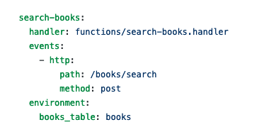

**Lambda Function – A New Function “search-books.js”**

1. Create a “**search-books.js**” file under the functions folder and copy the content from <https://bit.ly/2ROKU2b>. Save the file.

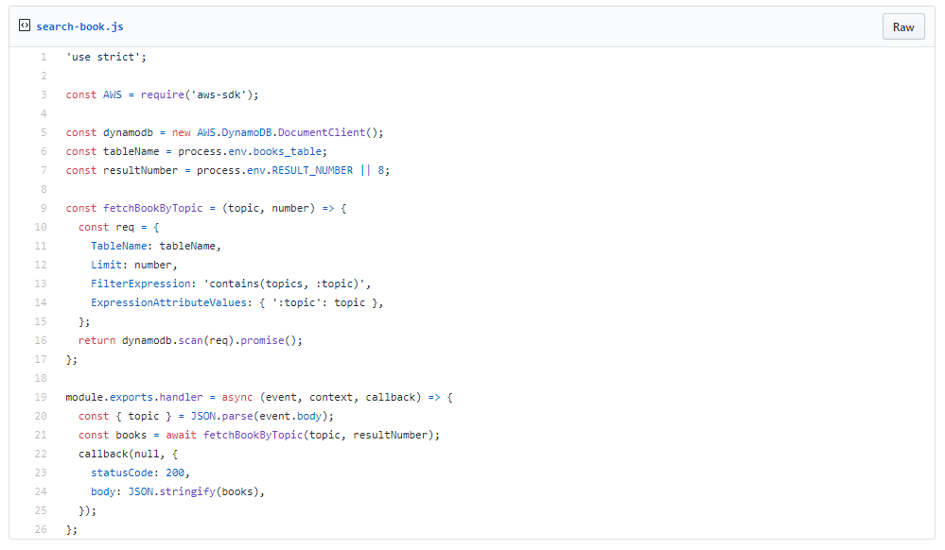

1. Open a terminal (press control and ~ keys) in VSCode and type “**sls deploy**” to deploy your new function. (**It may take a while based on your network speed**.)

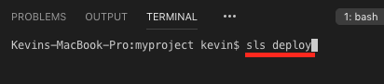

A new Lambda function was deployed.  
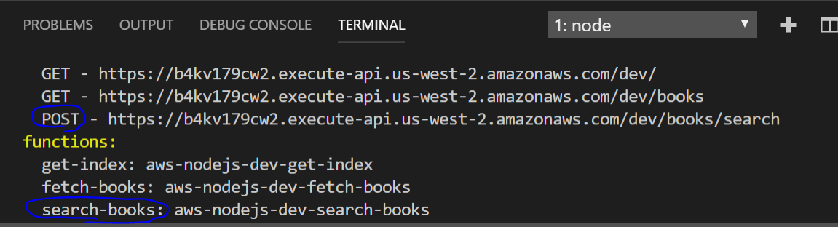

Note: you will have different URL endpoints.   
Record the URL for the new function (search-books).   
We will use it for the next step.

1. Paste the URL that you got from the previous step to the “serverless.yml”  
   Add “search_books_api:” to the correct place and paste your URL after “fetch_books_api:”

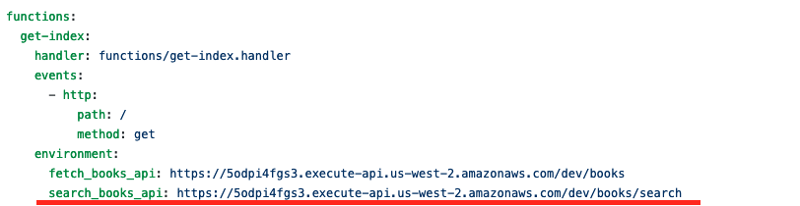

1. Access your “AWS Management Console” and visit your “Lambda” service.  
   Then, visit your Lambda function that you just created.

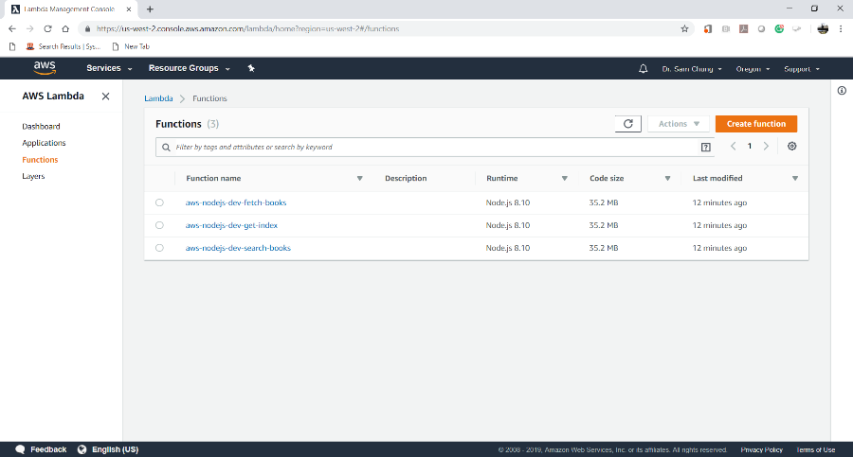

**User Interface – Update “index.html”**

1. Update the index.html with <https://bit.ly/2xOGDVF>

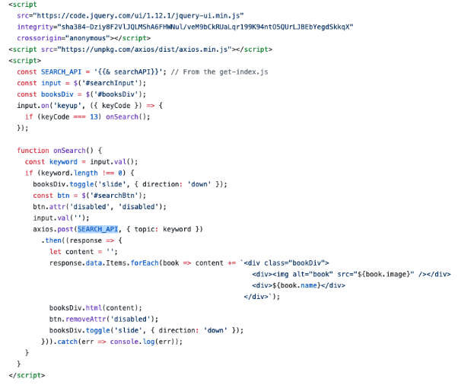

1. Type “**sls deploy**” in the terminal to deploy the change



1. Copy the URL of “ …/dev/” from “**endpoints**” and put it in the browser to invoke it or press “ctrl+click” to follow link.  
     
   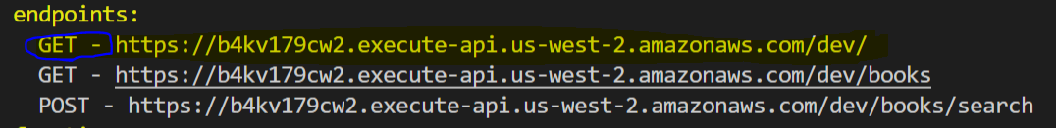  
   Note: you will have different URL endpoints.

**Testing - Web Application**

1. Try to put keywords such as “javascript” to the search input then click “Search” button.

|  |  |
| --- | --- |
|  |  |

1. Try to put keywords such as “data” to the search input then click “Search” button.

|  |
| --- |
|  |

1. Try to put keywords such as “python” to the search input then click “Search” button.

|  |
| --- |
|  |

**Push your work to GitHub**

Open the terminal from the VSCode by hit the control + ~ key and type the following command:

Run the following commands to push your work to the GitHub repository:

>>> git add .

>>> git commit -m “Submission for Module 5”

>>> git push origin YOUR_BRANCH_NAME

**Note**: you should change the YOUR_BRANCH_NAME to your own branch name. It should be firstname-lastname (e.g. maria-gracia).

If you cannot remember, run the command “git status” to check